|  |  |  |  |
| --- | --- | --- | --- |
| **Group name** | EUROPEAN TARRIF - LVCLA17-2025-2026-EUR- 18D17N-BEST OF INDOCHINA | **Code** | 240925134759 |
| **Version** | 1 | **Sales consultant** | Sales Team |
| **Group size** | 2 - 20 pax(s) | **Validity** | 1 Jan 2025-31 Dec 2026 |

LVCLA17-2025-2026-EUR-18D17N-BEST OF INDOCHINA

**Day 1**: **VIENTIANE ARRIVAL (-/-/-)**

Upon arrival at **Vientiane airport**, transfer to your hotel for check in (after 14:00) Free at leisure

# Overnight in Vientiane

**Day 2**: **VIENTIANE TOUR – BUDHA PARK (B/-/D)**

In the morning, we will first visit **Wat Si Muang**, which is very famous for its supernatural power. We then transfer out to see **Buddha Park**, an enchanting collection of Buddhist and Hindu sculptures on the Mekong Riverside meadow, close to the Friendship Bridge. There are approximately 200 religious images dating back over 500 years, which were created by a mysterious monk spreading his philosophy on life and revealing his ideas about the universe.

In the afternoon, we see the major sights of the capital; including the oldest **Wat Sisaket**, the temple with thousands of miniature Buddha statues and the former royal temple of **Wat Prakeo**, which previously housed the famous Emerald Buddha Image. On the way to Lao’s national icon, the famous and sacred structure of **That Luang Stupa**, we stop enroute to take some pictures of the imposing **Patuxay** Monument, which is well known as Vientiane’s own Arc de Triumph. A spectacular view over the Mekong River at sunset is a perfect way to finish the day.

# Overnight in Vientiane

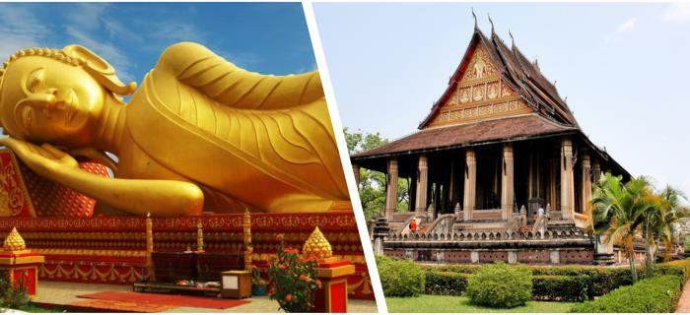

That Luang Stupa Wat Phrakeo

**Day 3**: **VIENTIANE – LUANG PRABANG BY SPEED TRAIN – CITY TOUR (B/-/-)**

After breakfast, we then transfer out to the train station to take the **train to Luang Prabang (08:08- 09:53)**

On arrival in Luang Prabang, our guide will take you on an in-depth walking tour of the city.

The walk is oriented towards **the lesser-known parts of the town** including charming lanes showing the more traditional atmosphere of the heritage town.

Along the way, we will see the **four different types of buildings categorized by UNESCO**.

The first one is the **traditional Lao house** which is made from tropical hardwood or bamboo and built on stilts.

The second is a **half wood and half cement house** built after the arrival of the French.

The third is the **traditional French colonial building** that are similar to those found in Vietnam and Cambodia.

The last form of architecture you will see is the **old Chinese shop houses** that were built to be used for both commercial and residential purposes.

We then continue with a visit to the **Royal Palace Museum**, which hosts a range of interesting artifacts. From there, we walk to the nearby **Wat Mai**, which is one of Luang Prabang’s largest and most richly decorated temples.

Late afternoon, we climb up to the top of **Mount Phousi** for an enjoyable exploration of the sacred, gilded stupa as well as a panoramic sunset view of the city and the Mekong River.

The tour ends after a visit to the famous **Night Market**, where you can find a lovely selection of handmade textiles made by local and hilltribe people surrounding Luang Prabang.

# Overnight in Luang Prabang

**Day 4**: **LUANG PRABANG – PAK OU CAVES (B/-/-)**

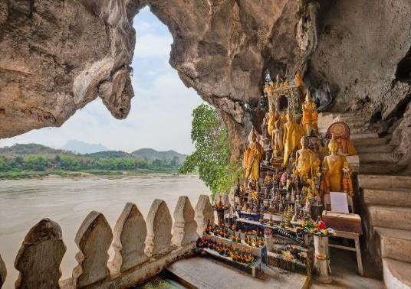After breakfast, we embark on a leisure cruise upstream on the Mekong River, which also gives us a breathtaking view of the tranquil countryside, before reaching the mysterious **Pak Ou Caves**, two linked caves crammed with thousands of gold lacquered Buddha statues of various shapes and sizes left by pilgrims.

Along the way, we stop at the **village of Ban Xanghai**, where they make the local rice wine.

On arrival back in the city, we will visit the old **Wat Sene** and the nearby magnificent **Wat Xiengthong** a superb piece of Lao temple

architecture, which presents a sweeping two-tiered roof and ornate mosaics including a beautiful

‘tree of life ‘glass montage on the rear temple wall.

Continue our visit to the **Traditional Arts and Ethnology Centre** to learn about Laos’ many ethnic

cultures.

Next, we will visit **Heuan Chan**, a 19th-century aristocratic mansion that offers a glimpse into Lao culture through traditional ceremonies, textiles, and family life. This restored mansion stands as a testament to Lao heritage, featuring enriching exhibitions and a documentary on Laos' customs. After the visit, we'll have the opportunity to taste authentic Lao coffee or tea, providing a true taste of Laos. **Overnight in Luang Prabang**

**Day 5**: **LUANG PRABANG – KUANG SI – FLIGHT TO HANOI (B/-/-)**

*Wake up as the sun rises, we will prepare to join the most sacred tradition of Laos, the daily morning alms giving, which dates to the 14th century. More than 200 Buddhist monks depart from various temple to gather their daily meal from the faithful residents sitting quietly on the streets.*

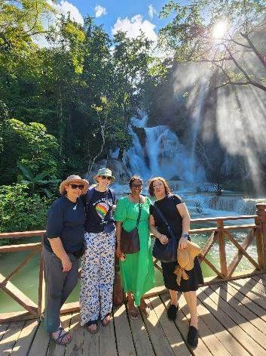

*Kuang Si Waterfall*

*We then visit the temporary morning market near the former Royal Palace which offers a glimpse into daily life, with vendors selling fresh produce, handmade crafts, and textiles. These experiences provide a unique and authentic cultural immersion.* After breakfast at the hotel, transfer directly to the **beautiful Kuang Si**, which is the biggest waterfall in the Luang Prabang area with three tiers leading to a 50-metre drop into spectacular azure pools before flowing downstream. The pools also make great swimming holes and are very popular with both tourists and locals

There is also the chance to walk to the nearby **village of Ban Thapene**, and explore the hidden waterfalls, which is rarely visited by other tourists

If you wish, take a short visit to the **Bear Rescue Center**, which houses a couple of dozen animals rescued from the hands of poachers and traffickers.

Returning to town, we make a brief stop at the **Ock Pop Tock Living Craft Center**, nestled peacefully by the Mekong River. Here, artisans craft high-quality fabrics using traditional techniques. You're encouraged to enhance your experience with a complimentary audio guide detailing the center's significance in Lao culture and history.

Then, transfer to Airport to take flight to Hanoi, upon arrival check in hotel

# Overnight in Hanoi

### *Suggestion Flight: QV313 LPQ HAN 17:25 18:35 (Airfare excluded on our price)*

**Day 6**: **HA NOI CITY TOUR (B/L/-)**

This full day tour takes you around **Ha Noi 's** most interesting sights, including the **Ho Chi Minh Complex** *(Closed on Mondays, Fridays and every afternoon)*, **Ho Chi Minh's Mausoleum and his Stilt House, Presidential Palace** and the **One Pillar Pagoda ,Tran Quoc Pagoda**. Continue your trip with the **Temple of Literature, Ngoc Son Temple**, and one of the city's museums, either the **History Museum or the Ethnology Museum**.

Also visit the **Old Quarter** known for its 36 streets and former craft guilds.

## Overnight in Hanoi

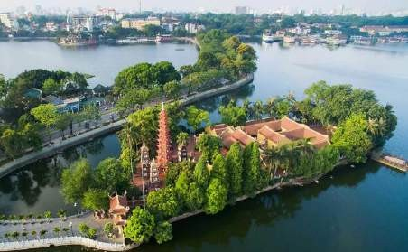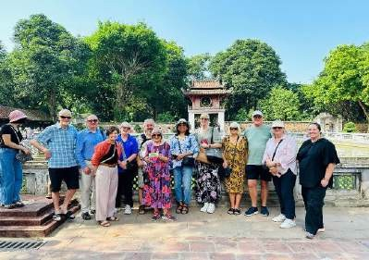

*Tran Quoc Pagoda Temple of Literature*

**Day 7**: **HA NOI - HA LONG ON CRUISE (B/L/D)**

Breakfast at your hotel. Morning depart for Ha Long Bay, we go through the scenic countryside. The wondrous Ha Long Bay is truly one of Vietnam's most impressive scenic sights. Heading out of the town we embark on a boat for an exploration of the legendary Ha Long Bay.Cruise amongst the bay's rock formations and floating villages. As the sun sets, enjoy dinner onboard and your boat will anchor in the bay for the night.

## Overnight on cruise

*Note: The itinerary of Halong will be changed based on which cruise you choose and depending on the weather without prior notice.*

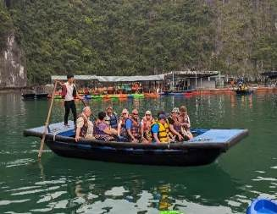

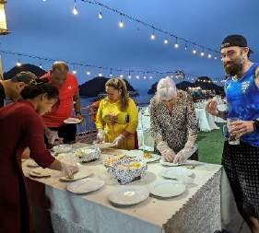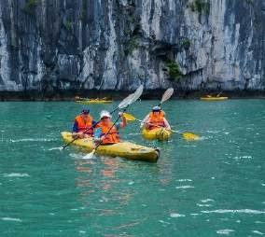

Kayaking *Cooking class Bamboo boat*

**Day 8**: **HA LONG BAY CRUISE - HA NOI – FLIGHT TO HUE (BRUNCH/-)**

Wake up early and see daylight filtering through the mist and towering rock formations, leaving you with a dream-like memory of your visit to Ha Long Bay. Enjoy a breakfast and perhaps join a Tai Chi class on the boat's deck before disembarking and Transfer to Airport for flight to Hue.

Upon arrival transfer to hotel for check in, free at leisure

## Overnight in Hue

*Note: the itinerary of Halong will be changed based on which cruise you choose and depending on the weather without prior notice.*

### *Suggestion Flight: VN1545 HAN HUI 16:35 17:50 (Airfare excluded on our price)*

**Day 9**: **HUE FULL DAY TOUR (B/-/-)**

After breakfast, you will be transferred to Hue for a tour including the **Citadel** and the **Forbidden Purple City**, the **Imperial Museum** and **Dong Ba Market.**

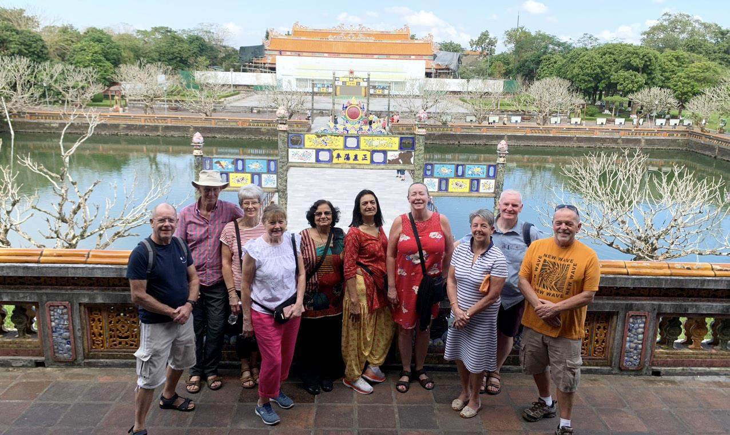

Hue Historic Citadel

Then, We will continue visit **Thien Mu Pagoda** and visit **King Tu Duc's Tomb** who ruled Hue more than 100 years ago, built his tomb when he was still alive and used it for meditation, reading and theater performances. **Overnight in Hue**

**Day 10**: **HUE – DANANG - HOI AN ANCIENT TOWN (B/L/-)**

After breakfast, transfer from Hue to Hoian.

Visit Hoian Ancient Town with a walking tour and visit private house where members of the same family have lived continuously for centuries in the traditional way.

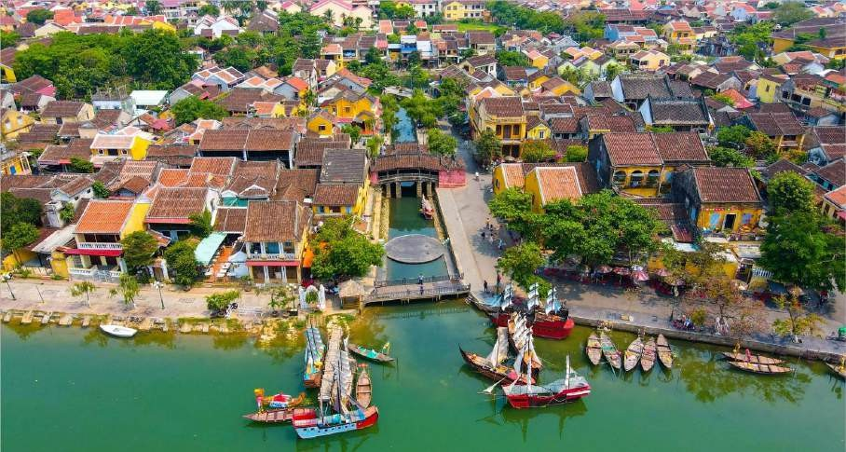

Japanese Covered Bridge Pagoda

Visiting **Family Chapel** built by prominent, merchant or official families as the center ancestor worship a Chinese style Pagoda or **Assembly Hall, Japanese Covered Bridge Pagoda**.

You have chance to **hand-on lantern Overnight in Hoi An**

**Day 11**: **HOIAN - BANA HILL WITH GOLDEN BRIDGE - HOIAN (B/-/-)**

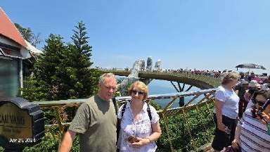

Golden Hand Bridge in Ba Na Hills

After breakfast at hotel, transfer to **Ba Na Hills**

Arrive at the cable car station Suoi Mo. Sitting in the cabin, in mid air, looking upon the endless tree lone of the forest. Experiencing the pristine ecological system of the Ba Na mountain will leave you a sense of unforeseeable discovery

Visit the Le Jardin, old wineries (excluded expenses) - remains of French Villas and Linh Ung pagoda with 27m high Buddha statue. Leave Le Jardin for Gare Debay, the second cable car station, to go to the top of Ba Na Visit and play game at the Fantasy Park- Ba Na Hills Fantasy Park- the third largest indoor amusement park in the world (Only some free games depending on Ba Na policy)

Free around Ba Na Hill till go down to the foot of mountain

Then transfer back to Hoian

## Overnight in Hoi An

**Day 12**: **HOI AN- DANANG – FLIGHT TO SAI GON – HALF DAY CITY (B/-/-)**

After breakfast, transfer to Da Nang Airport to take a flight to Sai Gon.

Upon arrival, visit the famous Saigon landmarks: the **Cathedral of Notre Dame** as well as the **Centre Post Office** and pass by the ornate **City Hall** (Hotel De Ville) and old **Opera House**. Visit **War Remnant Museum**. Finally, end up at the centre **Ben Thanh Market**, where vendors display a vast variety of traditional goods and handicrafts.

## Overnight in Saigon

### *Suggestion Flight: VN115 DAD SGN 10:10 11:40 (Airfare excluded on our price)*

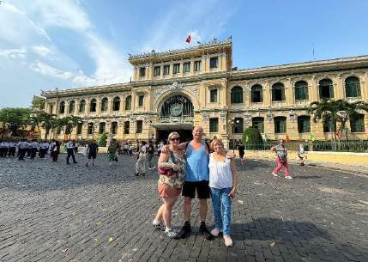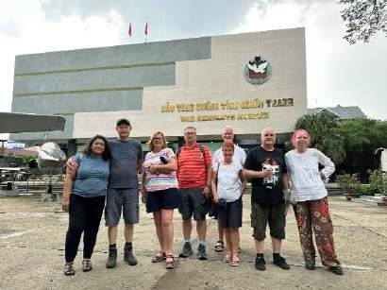

*Central Post Office War Remnants Museum*

**Day 13**: **TAY NINH – CUCHI TUNNEL (B/L/-)**

In the morning, leave Ho Chi Minh for **Cao Dai Temple in Tay Ninh** - a province 95 kms South East of HCMC, close to Cambodia border. The Cao Dai Temple is like a Walt Disney fantasia of the East. Its exterior is decorated with multi-colored dragons of all shapes and sizes competing for space with a number of swastikas. Above the main entrance is the all-seeing holy eye, the symbol of the Cao Dai sect. The interior is just as engaging as statues of Jesus Christ, Buddha and the Hindu god, Brahma, stand side by side.

Cao Dai Temple is the eclectic mix of colours and the amazing use of architecture create a space of beauty, spirituality with a somewhat surreal flavour to western palates!

For the midday service which was unbelievable in Cao Dai Temple - do not miss this!

Then, visit **Cu Chi Tunnels** which had never been discovered by American forces. The Cu Chi Tunnels were an important Vietcong base during the American War. Stretching over 200 km, this incredible underground network, dug by hand out of hard laterite, connected command posts, hospitals, shelter and weapon factories. Then we will drive to visit **Cao Dai** before transfer back to Saigon.

## Overnight in Saigon

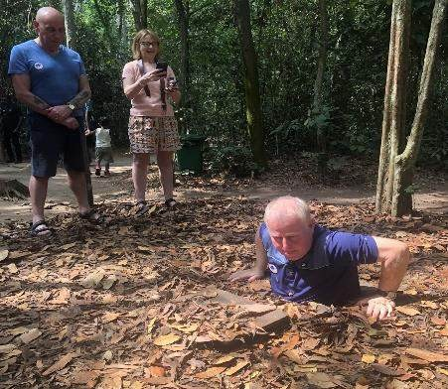 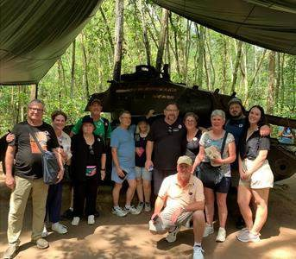

*Cu Chi Tunnels*

**Day 14**: **SAI GON – FLIGHT TO PHNOM PENH (B/-/-)**

Arrival at the airport, meet with guide and driver. Visit to **Royal Palace** is a royal residence now where His Majesty, the King of Cambodia, and the royal families live. it is like a small town of royal dynasties. Continue to **Silver Pagoda,** serves less as a functioning temple than a repository for cultural treasures such as 90 kg golden Buddha encrusted with 2086 diamonds.

## Overnight in Phnom Penh

### *Suggestion Flight: VN3855 SGN PNH 13:00 14:00 (Airfare excluded on our price)*

**Day 15**: **PHNOMPENH TOUR – SIEM REAP BY PRIVATE CAR (B/-/-)**

Breakfast at the hotel. Visit **Tuol Sleng Museum (S-21 prison).** This former school was used as a prison by Pol Pot’s security forces. More than 17,000 people held at S-21 were taken to the extermination camp at **Choeng Ek** to be executed. Then drive to visit the **“Killing Fields” of Choeng Ek** (15 km south of Phnom Penh). Between 1975 and 1978 about 17,000 men, women, children and infants (including nine westerners) were detained and tortured at the S-21 prison and transported to extermination camp of Choeng Ek. After that, transfer to Siemreap by private car.

## Overnight in Siem Reap

**Day 16**: **SIEM REAP (B/-/-)**

Breakfast at hotel: Start your sightseeing tour of **Angkor area** we spend a full day exploring the wondrous ancient ruins with the **South Gate of Angkor Thom,** which is famous for its series of colossal human faces carved in stone, the impressive **Bayon Temple, the Royal Enclosure, Phimeanakas, the Elephant Terrace, the Terrace of the Leper King** and the largest as well as the most complete temple of **Angkor Wat.** This architectural masterpiece was constructed in the 12th century and covers an area of about 210 hectares. We

stroll around this massive edifice, seeing the many galleries with columns, libraries, pavilions, courtyards and ponds full of water reflecting the towering temple and the jungle covered temple of **Ta Prohm** is an incredible sight. There are enormous fig trees and gigantic creepers which embrace themselves in the stone foundations of the structure giving the impression of man's creation being reclaimed by the powerful forces of nature.

## Overnight in Siem Reap

***Note:*** *During the visit of the Bakan Tower of Angkor Wat Temple*

* *Visitors are required to wear proper attire, covering shoulders and knees (no short, miniskirt or short trousers).*
* *Visitors have to be in the queue and waiting to climb up the Bakan Tower of Angkor Wat*
* *Children under twelve years old are not allowed to climb up this tower.*
* 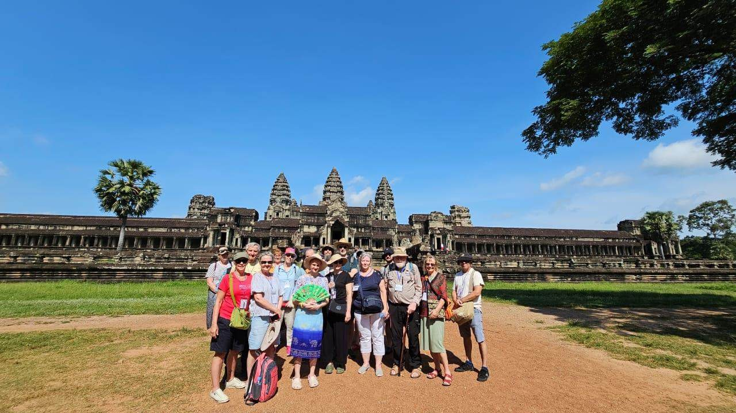*It will be closed on the Buddhist Sabath Days, the Buddhist religious days (four days a month).*

Angkor Wat temple

**Day 17**: **SIEM REAP TOUR (B/-/D)**

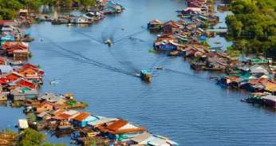Visit to **Floating Village**, take a ride by traditional wooden boat on **Tonle Sap Lake** to experience the human occupations at the edges of the lake is similarly distinctive –

floating villages, towering stilled houses, huge fish traps, and an economy and way of life deeply intertwined with the lake, the fish, the wildlife and the cycles of rising and falling waters. In the wet season, the Tonle Sap Lake is one of the largest freshwater lakes in Asia. On the way back, visit the **Western Baray (Baray Occidental)** measuring 8 km by 2.3 km which provided water for the intensive cultivation of lands around Angkor.

Dinner with Apsara Show Tonle Sap lake

## Overnight in Siem Reap.

**Day 18**: **SIEM REAP DEPARTURE (B/-/-)**

Free at your leisure until transfer to the airport for your onward flight (check out time: 12:00 noon)

**End of services!**

**List of accommodations**

|  |  |  |
| --- | --- | --- |
| **Location** | **4\*** | **5\*** |
| Vientiane | SureStay By Best Western**** (Superior) | Crowne Plaza***** (Standard) |
| Luang Prabang | Le Bel Air Resort**** (Garnier) | Pullman Hotel***** (Deluxe) |
| Ha Noi | Sunway, Lacasa hotel, MK Premier **** (Deluxe)/ROH) | Pan Pacific ***** (Deluxe) |
| Ha Long | Indochina Sail, Crown Legend, Calypso (Deluxe) | Indochine cruise; Paradise Elegance, Paradise Grand  ROH |
| Hue | Romance,Moonlight, Huong Giang**** (ROH) | Silk Path Grand Hue***** (Deluxe) |
| Hoian | Silkotel, Hoian Central, Hoian Historic, Wyndham Garden****(Deluxe) | Palm Garden/ Allegro***** (ROH) |
| Sai Gon | Paragon/ Kin / Northen charm **** (ROH) | New World / Pullman***** (ROH) |
| Phnom Penh | Sunway Hotel **** (Deluxe) | Palace Gate Hotel& Resort***** (Apsara Deluxe) |
| Siemreap | Saem Siem Reap**** (Deluxe) | Sofitel Angkor Phokeethra Golf & Spa***** (Superior) |

**Rates and Conditions**

Prices are in USD per person, based on two guests sharing a twin or double room in the hotels mentioned above.

Below rates are not valid for the period of Christmas, New Year (normally from 20 Dec to 10/ 15 Jan), Chinese/ Vietnamese New Year, Independence Day (30 April), May Day, National Day (02 Sep), Songkran festival (13-16 April), Golden Week (01-07 Oct), Loy Kratong (10-14 Nov), Myanmar Water Festival or Myanmar New Year (10-20 Apr), etc. Please contact us for further details in terms of specific dates.

|  |  |  |  |  |  |  |  |  |  |
| --- | --- | --- | --- | --- | --- | --- | --- | --- | --- |
| **High Season**  ***01 Jan 2025 – 30 Apr 2025 & 01 Oct 2025 – 31 Dec 2025*** | | | | | | | | | |
| **Group size/ Price per person in**  **USD** | **2** | **3** | **4** | **5-7** | **8-9** | **10-**  **15** | **16-**  **20** | **21-**  **25** | **SGL**  **supplement** |
| ***NO FOC*** | | | | | | ***1 FOC in twin*** | |
| **4\*** | 2,469 | 2,085 | 1,861 | 1,746 | 1,641 | 1,577 | 1,560 | 1,485 | 803 |
| **5\*** | 3,347 | 2,903 | 2,684 | 2,588 | 2,465 | 2,402 | 2,426 | 2,361 | 1,570 |
| **Low Season**  ***01 May 2025-30 Sept 2025*** | | | | | | | | | |
| **Group size/ Price per person in**  **USD** | **2** | **3** | **4** | **5-7** | **8-9** | **10-**  **15** | **16-**  **20** | **21-**  **25** | **SGL**  **supplement** |
| ***NO FOC*** | | | | | | ***1 FOC in twin*** | |
| **4\*** | 2,347 | 1,968 | 1,744 | 1,628 | 1,523 | 1,461 | 1,438 | 1,366 | 692 |
| **5\*** | 3,069 | 2,689 | 2,465 | 2,364 | 2,241 | 2,183 | 2,193 | 2,126 | 1,329 |
| **Extra Cost For Flight Ticket**  **(Airfare could be changed without prior notice)**  **-** *Luangprabang – Hanoi: 190-210-230USD/pax*  **-** *Hanoi-Hue: 90USD-100USD-110USD-120USD/pax*  **-** *Danang-Saigon: 90USD-100USD-110USD-120USD/pax*  **-** *Saigon-Phnompenh: 160-180-200-220USD/pax* | | | | | | | | | |

**High Season**

***01 Jan 2026 – 30 Apr 2026 & 01 Oct 2026 – 31 Dec 2026***

|  |  |  |  |  |  |  |  |  |  |
| --- | --- | --- | --- | --- | --- | --- | --- | --- | --- |
| **Group size/ Price per person in**  **USD** | **2** | **3** | **4** | **5-7** | **8-9** | **10-**  **15** | **16-**  **20** | **21-**  **25** | **SGL**  **supplement** |
| ***NO FOC*** | | | | | | ***1 FOC in twin*** | |
| **4\*** | 2,481 | 2,100 | 1,878 | 1,764 | 1,659 | 1,596 | 1,581 | 1,506 | 811 |
| **5\*** | 3,360 | 2,979 | 2,756 | 2,659 | 2,534 | 2,470 | 2,498 | 2,431 | 1,609 |
| **Low Season**  ***01 May 2025-30 Sept 2025*** | | | | | | | | | |
| **Group size/ Price per person in**  **USD** | **2** | **3** | **4** | **5-7** | **8-9** | **10-**  **15** | **16-**  **20** | **21-**  **25** | **SGL**  **supplement** |
| ***NO FOC*** | | | | | | ***1 FOC in twin*** | |
| **4\*** | 2,378 | 1,997 | 1,774 | 1,659 | 1,554 | 1,491 | 1,470 | 1,397 | 709 |
| **5\*** | 3,113 | 2,732 | 2,509 | 2,408 | 2,285 | 2,226 | 2,239 | 2,171 | 1,360 |
| **Extra Cost For Flight Ticket**  **(Airfare could be changed without prior notice)**  **-** *Luang Prabang – Hanoi: 190-210-230USD/pax*  **-** *Hanoi-Hue: 90USD-100USD-110USD-120USD/pax*  **-** *Danang-Saigon: 90USD-100USD-110USD-120USD/pax*  **-** *Saigon-Phnompenh: 160-180-200-220USD/pax* | | | | | | | | | |

## Child policy:

* + Infant (under 2 years old) : Free of charge (sharing bed with their parents, 01 child maximum in the double/ twin room and maximum 2 children in one group)
  + Child from 02 – 10 years old
    - *With extra bed or mattress on Halong Cruise: 75% rate of adult*
    - *Without extra bed : 65% rate of adult*
    - *Child in twin room : 90% rate of adult*
  + Child 11 years old and above : 100 % rate as adult

|  |  |
| --- | --- |
| **Inclusions** | **Exclusions** |
| * Accommodation in the category chosen or similar (subject to availability) | * International flight tickets and airport taxes. |

|  |  |
| --- | --- |
| * Meals as mentioned in the program. B= Breakfast, L=Lunch, D=Dinner * All local boat rental as mentioned in the program. * Cruise 01 nigh on non-private junk in Ha Long Bay * 2 ways cable car Bana Hill * Speed Train Luangprabang-Vientiane (2nd class of train) * Transportation by private vehicle with A/C. * All entrance fees and sightseeing as mentioned in the program. * Local English speaking guide(s) as mentioned   (In house sharing English speaking guide on cruise in Halong Bay. If you need our private guide, please let us know, we will advise you any surcharge on cruise)   * Mineral water with 2 bottles of 500ml/ tour day/ pax. |  |
| * Flight ticket Luangprabang-Hanoi//Hanoi- Hue//Danang-Saigon//Saigon-Phnompenh * Meals and drinks which are not mentioned in the program * Drink & Beverage in meals * Optional tours * Travel insurance (Please make sure that you buy insurance for your clients before they travel oversea) * Visa arrangement & Visa stamp at international gate * TIPPING for local guide and van driver * 1 pax: 15 USD/ pax/ day * 2 - 4 pax: 10 USD/ pax/ day * 5 pax up: 6 USD/ pax/ day   *Suggested TIPPING for bellboy, boat crew, sampan driver: depend on your satisfaction   * Any services not clearly mentioned in the program |

## GENERAL TERMS & CONDITIONS

**Remarks for check in and check out schedules**

Check in time: at hotel: after 14h00 – on cruise: before 12h00. Check out time: at hotel & on cruise: before 12h00

## Remarks for itinerary

The itinerary and schedule are subject to change due to local traffic situations, weather conditions; flight, or any un-foreseen circumstances or local authority decision. LV Travel reserves full rights to replace all items with same values for guests.

## Remarks for meal

Meals are fusion on local food with daily normal buffet breakfast at hotel. Guests should advise any special food preferences, allergies or dietary requirements at least one (1) week prior to the arrival date.

## Remarks for the price

16 full paying pax group is granted one FOC based on half twin (exclusive of extra service).

Please be aware that any changes in the itinerary due to unforeseen circumstances might result in increase in pricing.

Any damage caused to all services during the stay shall be payable by the passengers.

## Validity

All prices quoted to the Client/Agent are on a net basis in United States Dollars and valid according to the date specified on the LV Travel printed tariffs and/or quotation and/or invoice issued to the Client/Agent. LV Travel warrants that the prices or rates quoted to the Client/Agent are correct at the time of issuance or invoice but are subject to change in line with market, tax or currency fluctuation, with or without prior notice.

## Payment method

Unless otherwise agreed by LV Travel, client’s payment shall be executed by **bank transfer**, to the LV travel’s bank account clearly noted in all the invoices. Every party shall take care of the transfer fees occurring with its relevant bank.

**Payment conditions for domestic or international flights** : We will check case by case.

## Payment conditions for land tour without flights:

-Upon the confirmation of the document: a deposit of 30% total price is required 03 months prior to the

group’s arrival in Indochina, in order to secure all services

* The full payment of entire 70% of the total price must be transferred to the LV travel’s bank account 30

days prior to the group arrival in Indochina, if not agreed otherwise. **Cancellation of domestic or international flights:** We will check case by case. **Cancellation policy:**

* All cancellations should be made in writing and should be acknowledged by LV travel.

-Cancellation Rules for Land Tour, not apply for **domestic or international flights** (if any).

* Cancellation more than 45 days prior to the group arrival: No Charge. Deposit shall be deducted into the next bookings, except specified suppliers require cancellation fees.
* Cancellation between the 45th and 31st day prior to the group arrival: 25% of the total tour price.
* Cancellation between the 30th and 23rd day prior to the group arrival: 30% of the total tour price.
* Cancellation between the 22nd and 16th day prior to the group arrival: 40% of the total tour price.
* Cancellation between the 15nd and 09th day prior to the group arrival: 60% of the total tour price.
* Cancellation between the 08nd and 03rd day prior to the group arrival: 80% of the total tour price.
* Cancellation between the 02nd and 0th day prior to the group arrival: 100% of the total tour price.
* In case the tour participant(s) shorten or interrupt the tour of their own accord there will be no reimbursements.
* Reduction in the number of passengers against requested bookings is considered and treated as cancellations.
* If the balance of the tour invoice is not received by the deadline of 14 days prior to the group arrival, LV Travel will reserve the right to cancel the reservation without indemnity or any reimbursement.
* If LV Travel is forced to cancel the departure due to unforeseeable reasons, the participants will be fully reimbursed without intention to claim for any indemnities.

|  |  |
| --- | --- |
| **Contact details** | |
| Hotline for sales (ms Moon) | +84 888 905 286 (WA/viber/mobile) |
| Hotline for operation (ms Anna Hanh) | +84 983 096 032(WA/viber/mobile) |
| General Manager Mr Len | +84 989 200 116 (WA/viber/mobile) |